January 10 – Friday 8:30 pm
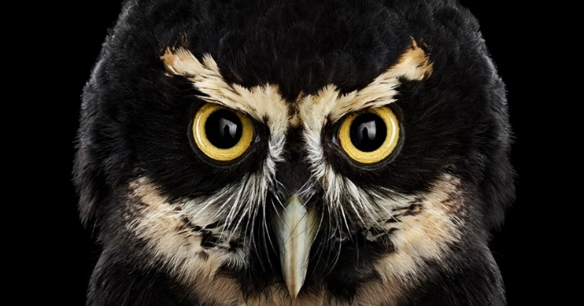
Hike – Full Moon Owl Walk
February 29 – Saturday – 10:00-11:30 am

Opossum
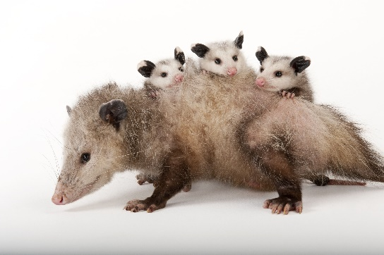

March 28 – Saturday – 10:00-11:30 AM
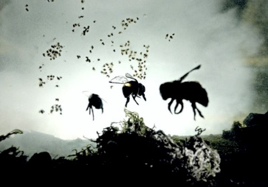
Hike – Bees
April 18 – Saturday – 10:00-11:30 AM
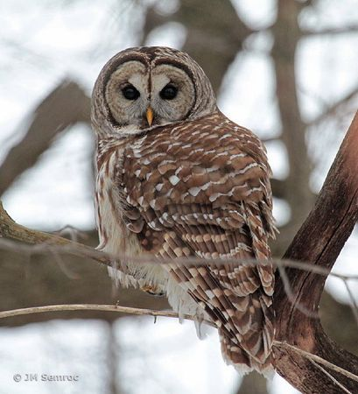
Owls- Guests bringing owls to see up close
May 30 – Saturday – 10:00-11:30 AM
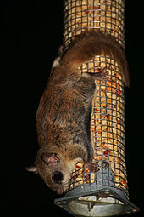

Squirrels

June 13 – Saturday – 10:00-11:30 AM
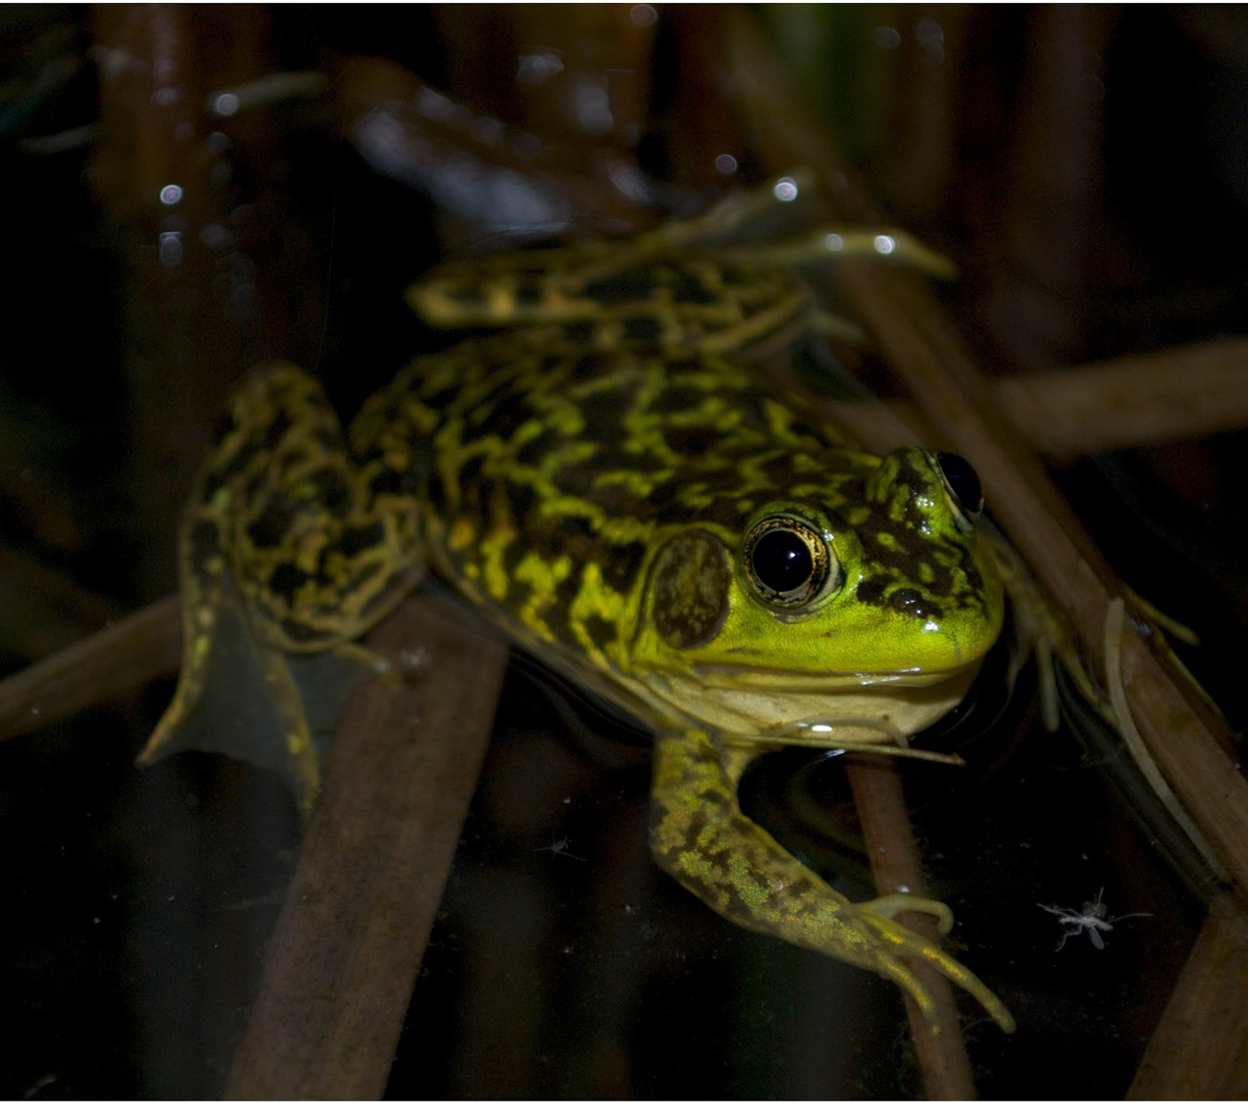

Crawdads/Frogs/Minnow Search in the creek
July 30 – Thursday – 8:00-9:30 pm
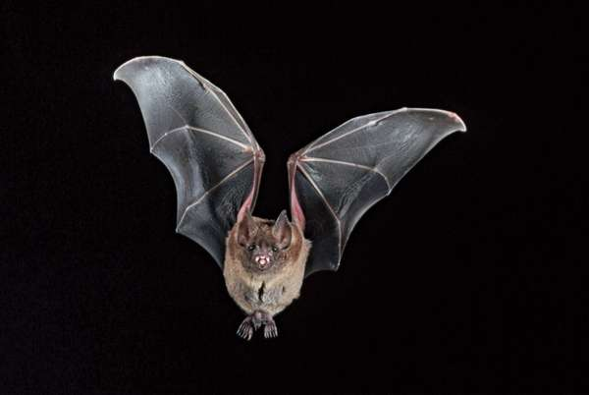
Bats – Guest Marne Titcheneli, Wildlife Program Specialist from OSU Extension
August 15 – Saturday 10:00-11:30 AM
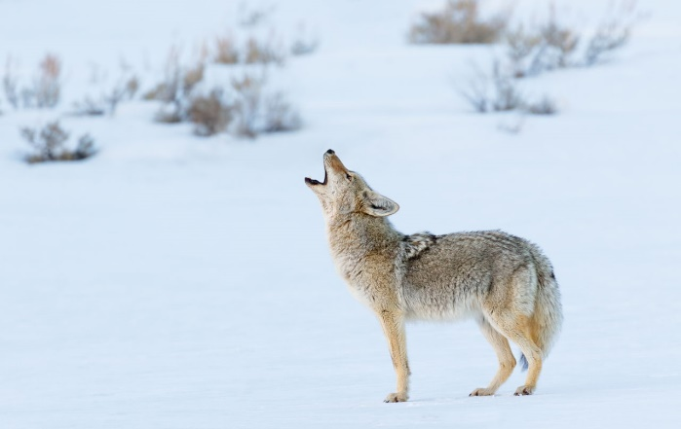
Coyote
Sept. 26 – Saturday – 10:00-11:30 AM
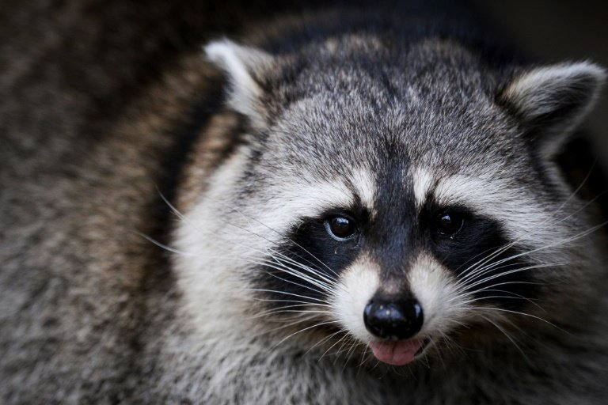

Racoons
October 24 – Saturday 10:00-11:30AM
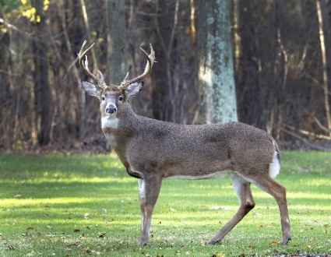
Fall Hike – Deer

November 21 – Saturday 10:00-11:30AM

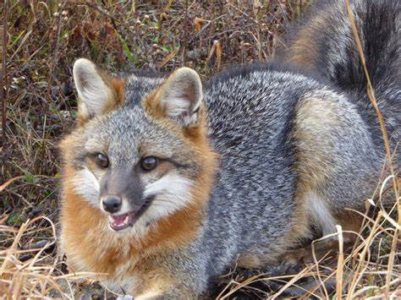

Gray Fox

2020 Education Programs at
Myeerah Nature Preserve
Once a month
Most are on Saturdays
10:00 am – 11:30 am
Families may participate in our Education Programs by purchasing a Family Membership for the year - $50.00 which will cover all family members participating in our activities for the year. You may also pay per session which would be $10.00 for a family or $5.00 for an individual. All are welcome to attend we have something interesting for all ages!!
For More Information please contact Bellefontaine Joint Recreation District at
937-592-3475.
Cancellation Line 937-651-6009
and
on our Facebook Page
“Bellefontaine Joint Recreation District” 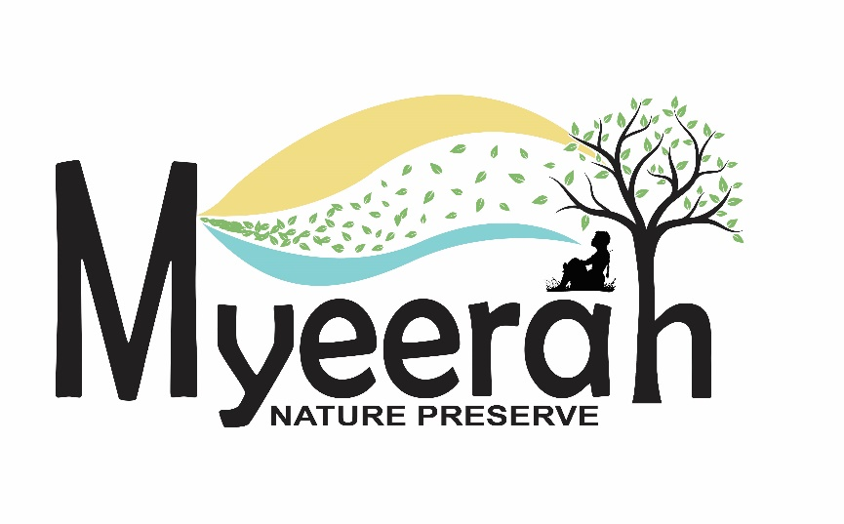
7405 SR 540
Bellefontaine OH 43311
MYEERAH
NATURE
PRESERVE
2020
EDUCATION PROGRAMS
Creature of the Night

